**EXPERIMENT 2**

**AIM:**  To create a LAMP instance in the AWS CLI.

1. Firstly, type sudo su to become the root user.

2. To update all the packages in your instance type “yum update -y

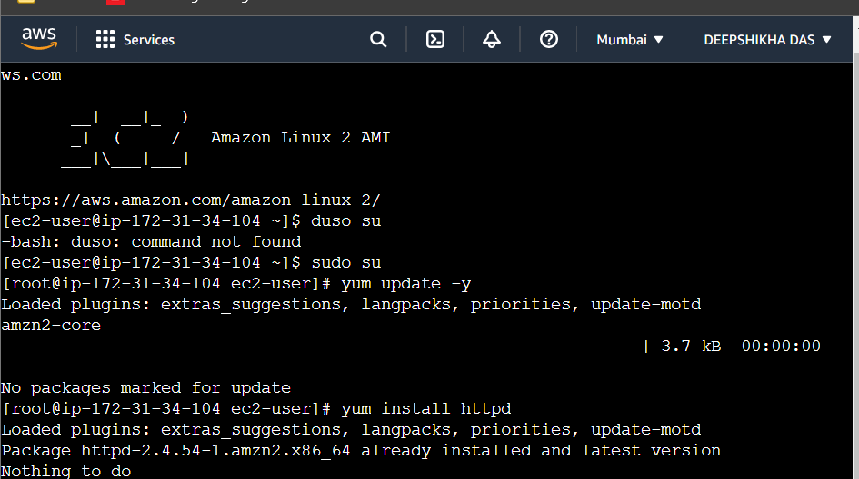

3. To install Apache server in linux, type “yum install httpd”.

4. To install mysql or mariadb type “yum install mariadb mariadb-server”.

5. To install php, type “yum install php php-mysql”.

6. Type “yum search php” to see all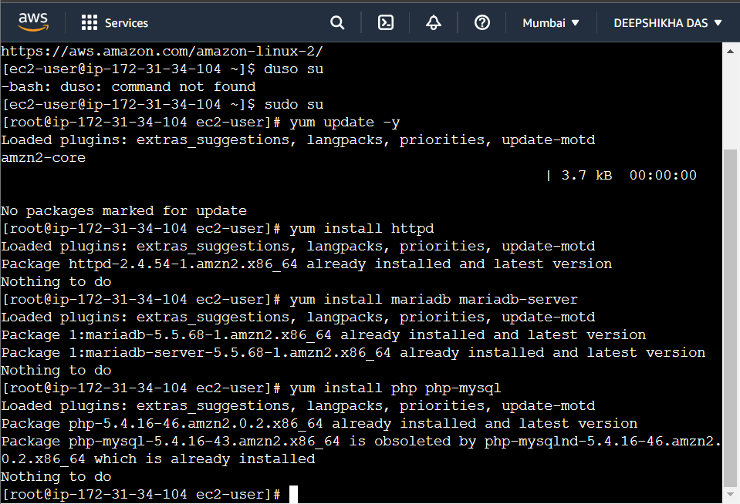 the packages installed in the server.

7. Enabling the mariadb server.

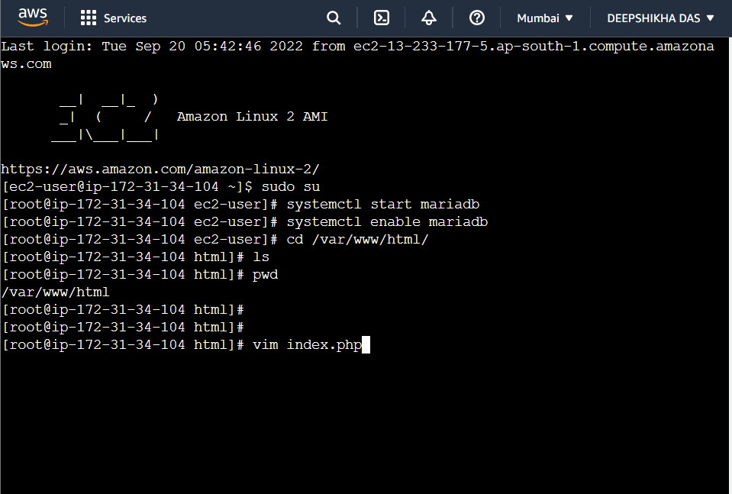

8. After enabling httpd (apache server) , go to the directory where cd /var/www/html/

9. Go to vim and type “<?php phpinfo(); ?>”.

